Definition: A compact representation of a trie corresponding to the suffixes of a given string where all nodes with one child are merged with their parents.

String Searching
The problem is to search for a pattern string, pat[1..m], in a text string txt[1..n]. Usually n>>m, and txt might be very long indeed, although this is not necessarily so. This problem occurs in text-editors and many other computer applications.
Naive Search
The naive string searching algorithm is to examine each position, i>=1, in txt, trying for equality of pat[1..m] with txt[i..i+m-1]. If there is inequality, position i+1 is tried, and so on.
The worst-case time-complexity of the naive algorithm is seen to be O(m*n),
e.g. pat=a^{m-1}b and txt=a^{n-1}b
Mercifully there are faster algorithms!
You need a browser with JavaScript ON!
Demonstration
The HTML FORM below allows you to search for a pattern string pat in a text string txt. It uses three algorithms: the naive algorithm (above), Rabin's algorithm and the Boyer-Moore algorithm (below). Change the values of pat and txt, run the algorithms and experiment:

pat:
txt:
-trace

Rabin's Algorithm
Rabin's string searching algorithm uses a "rolling hash". Hashing is an idea borrowed from hash- [tables] but used here without the "table". In Rabin's algorithm, the hash function is defined to compute a number in [0..p-1] for a large prime number p. The integers modulo p, Z_{p}, behave as a mathematical field. That is, they behave just as the usual unbounded integers do (see [intro']) with respect to addition and multiplication, and in particular there are no "divisors of zero", that is no non-zero values j & k such that j*k=0.
At each stage of the algorithm, hash(txt[i..i+|pat|-1]) is compared with hash(pat), e.g.
patHash = (((ord(pat[1])*3+ord(pat[2]))*3+...+ord(pat[m])
) mod p

txtHash₁= (((ord(txt[1])*3+ord(txt[2]))*3+...+ord(txt[m])
) mod p

txtHash_{i}= ((txtHash_{i-1} - ord(txt[i-1])*power)*3
+ ord(txt[i+m-1])
) mod p, where i>1

where power = 3^{m-1}
and ord(ch) is the character code of ch
If the values are equal then a match has almost certainly been found. A character by character check must be made to be absolutely sure.
Time Complexity
Rabin's algorithm is (almost always) fast, i.e. O(m+n) average-case time-complexity, because hash(txt[i..i+m-1]) can be computed in O(1) time - i.e. by two multiplications, a subtraction, an addition and a `mod' - given its predecessor hash(txt[i-1..i-1+m-1]).
The worst-case time-complexity does however remain at O(m*n) because of the possibility of false-positive matches on the basis of the hash numbers, although these are very rare indeed.
Space Complexity
Space complexity is O(1) for a few scalar variables.
Boyer-Moore Algorithm
The Boyer Moore algorithm is always fast having worst-case time-complexity O(m+n), but on natural-language text it actually gets faster as m increases to a certain extent, e.g. Boyer and Moore suggesting O(n/4)-time on average for m=5.
The first key idea, and it is a good one, is that if the m^{th} character ch=txt[m] (numbered from `1' upwards) does not occur in pat at all then any instance of pat in txt must start at position m+1 or later.
e.g. if searching for pat=`freddy', in txt=`I floated lonely as a cloud', the 6th character of txt is `a' which is not in {d,e,f,r,y} and there is no need to consider positions 1 to 6 of txt any more! In this way, we can move along txt in steps of m positions, i.e. k=m, 2m, 3m, ..., provided we are lucky.
The second idea is that if the last occurrence of the character txt[k] in pat is delta₁[ch] positions from the right hand end of pat, then pat can be slid that many positions to the right before we might get a match in txt. If ch=txt[k] does not occur in pat, set delta₁[ch] equal to m.
e.g. delta₁['e']=3, delta₁['f']=5, delta₁['d']=1, delta₁['r']=4, delta₁['y']=0.
In general if the last j characters match, i.e. txt[k-j..k]=pat[m-j..m], but txt[k-j-1]~=pat[m-j-1], then pat can be "slid" a certain distance along txt depending on where, if at all, there is an earlier instance of pat[m-j..m] within pat; e.g. consider pat=abracadabra, or e.g. pat=fababab. An array, delta₂[1..m], is used to hold these precomputed distances.
Time Complexity
The worst-case time-complexity of the Boyer-Moore algorithm is O(m+n).
The algorithm often runs in O(n/m)-time on natural-language text for small values of m. Note that if txt is in slow, block-access, backing store, it is generally not possible to bring just every m^{th} character into main memory, so the time-complexity is then O(n).
Space Complexity
The space-complexity is O(m + |alphabet|), for the arrays delta1[ ] and delta2[ ].
Preprocessing txt.
It is intuitively obvious that the worst-case for searching for an arbitrary pattern, pat, in a text, txt, must take at least O(n)-time, where n=|txt|. However, if some time is spent pre-processing txt, then individual searches can be made more quickly, e.g. in O(m)-time using a suffix-tree, where m=|pat|. It takes O(n)-time to build a suffix tree for txt.
Notes
- R. S. Boyer and J. S. Moore. A Fast String Searching Algorithm. Comm. A.C.M. 20(10) p762-772 Oct 1977.
The paper has a rather nice section on how the algorithm was developed, over quite some time, from the initial idea, with contributions from various people.
- D. E. Knuth, J. H. Morris and V. R. Pratt. Fast Pattern Matching in Strings. SIAM Jrnl. Comput. 6(2) p323-350 Jun 1997.
- R. M. Karp and M. O. Rabin. Efficient Randomized Pattern-Matching Algorithms. IBM Jrnl. Res. and Dev. 31(2) p249-260 Mar 1987.
- G. de v. Smit. A Comparison of Three String Matching Algorithms. Software Practice and Experience 12 p57-66 Jan 1982.
Compared (i) a straightforward algorithm, (ii) Knuth Morris Pratt algorithm, and (iii) the Boyer Moore algorithm. The last of these was usually best, by far.
- There are slight programming variations depending on whether strings are indexed from zero or from one.
- Beware: Some implementations of `m mod n' in some languages and systems are incorrect when m is negative which can cause a nasty surprise when implementing Rabin's algorithm!
- The [Suffix Tree] data structure for txt can be built in O(|txt|)-time and can then be used to find a substring, pat, in O(|pat|)-time.
- Also see the [edit-distance] problem, a.k.a. approximate string matching.

Suffix tree
From Wikipedia, the free encyclopedia
Jump to: navigation, search
/wiki/Image:Suffix_tree_BANANA.png￹FPRIVATE "TYPE=PICT;ALT=Suffix tree for the string BANANA padded with $. Suffix links drawn dashed."/wiki/Image:Suffix_tree_BANANA.png
Suffix tree for the string BANANA padded with $. Suffix links drawn dashed.
A suffix tree for a string S of n characters is a radix tree containing all n suffixes of S. Hence it is a substring index. It was first described by Weiner in 1973.[1] This data structure can be built in Θ(n) time, and gives you all z occurrences of a pattern P of length m in O(m + z) time, which is optimal. You can also extract a lot of information about your text data with a suffix tree. It was one of the first linear-time solutions for the longest common substring problem.
Contents
[hide]
- 1 Functionality
- 2 Uses
- 3 Description
- 4 References
- 5 External links
[edit]

Functionality
A suffix tree for a string S of length n can be built in Θ(n) time, if the alphabet is constant or integer [2]. Otherwise, the construction time depends on the implementation. Assume that a suffix tree has been built for the string S, or that a generalised suffix tree has been built for the set of strings D = {S¹,S²,...,S^{d}} of total length n = | S¹ | + | S² | + ... + | S^{d} | . Assume that the size of the alphabet Σ is σ.
You can:
- Check if a string P of length m is a substring of any of the strings in D in O(m) time.
- Find all z occurrences of P in D in O(m + z) time.
- Search for a regular expression P in time expected sublinear on D.
- Search for a pattern P in D with x mismatches in O(mσx + z) time.
- Find the longest common substrings of all strings in D in O(n) time.
- Find the most frequently occurring substrings of a minimum length in O(n) time.
- Find the shortest strings from Σ that do not occur in D, in O(n) time. (There might be O(nσ) such strings, so it takes O(nσ) time to report them explicitly).
[edit]

Uses
Suffix trees are mainly used in bioinformatics applications, where they are used for searching for patterns in DNA or protein sequences, which can be viewed as long strings of characters. The ability to search efficiently with mismatches might be the suffix tree's greatest strength. It is also used in data compression, where on the one hand it is used to find repeated data and on the other hand it can be used for the sorting stage of the Burrows-Wheeler transform. Variants of the LZW compression schemes use it (LZSS).
[edit]

Description
Before a string is indexed with a suffix tree, it is usually padded with a unique terminator, to make sure no suffix is a substring of another. Then you know that each suffix will be uniquely represented by a leaf node. The suffix tree for the string S is defined as the tree which has the property that edges spell non-empty strings, the paths from the root to the leaves have a one-to-one relationship with the suffixes of S, and all internal nodes except the root have at least two children. There are n suffixes, and hence n leaf nodes. Since all internal non-root nodes are branching, there can be at most n − 1 such nodes, and n + (n − 1) + 1 = 2n nodes in total. If each node and edge can be represented in Θ(1) space, the entire tree can be represented in Θ(n) space. The total length of the edges in the tree is O(n²), but each edge can be stored as the position and length of a substring of S. The worst-case space usage of a suffix tree is seen with a fibonacci string, giving the full 2n nodes.
The main choice when making a suffix tree implementation is the parent--child relationships between nodes. The most common is using linked lists called sibling lists. Each node has pointer to its first child, and to the next node in the child list it is a part of. Suffix tree construction time is O(nσ), and search time is O(mσ + z). Hash maps and arrays may also be used, giving different running time properties.
Suffix links are a key feature for linear-time construction of the tree, since they allow changes to propagate to all suffixes quickly. In a complete suffix tree, all internal non-root nodes have a suffix link to another internal node. If the path from the root to a node spells the string χα, where χ has length 0 or 1, it has a suffix link to the internal node representing α. See for example the nodes for NAN and AN in the figure above. Suffix links are used both in construction and in some algorithms running on the tree.
The large amount of information in each edge and node makes the suffix tree very expensive, consuming about ten to twenty times the memory size of the source text in a good implementations. The suffix array reduces this requirement to a factor of four, and researchers have continued to find smaller indexing structures.
[edit]

References
- E.M. McCreight. (1976). A space-economical suffix tree construction algorithm. Journal of the ACM 23 262-272.
- E. Ukkonen. (1995). On-line construction of suffix trees. Algorithmica 14(3):249-260. PDF
- ↑ Martin Farach (1997). "Optimal suffix tree construction with large alphabets". Foundations of Computer Science, 38th Annual Symposium on, 137-143.
- ↑ P. Weiner (1973). "Linear pattern matching algorithm". 14th Annual IEEE Symposium on Switching and Automata Theory, 1-11.

A trie (from retrieval), is a multi-way tree structure useful for storing strings over an alphabet. It has been used to store large dictionaries of English (say) words in spelling-checking programs and in natural-language "understanding" programs. Given the data:
an, ant, all, allot, alloy, aloe, are, ate, be
the corresponding trie would be:
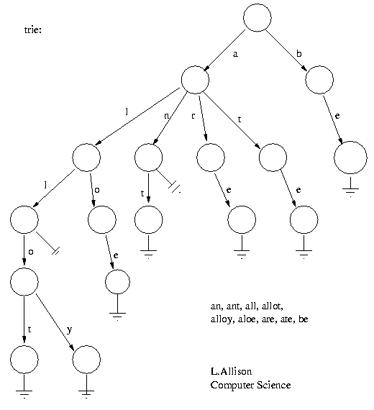
The idea is that all strings sharing a common stem or prefix hang off a common node. When the strings are words over {a..z}, a node has at most 27 children - one for each letter plus a terminator. The elements in a string can be recovered in a scan from the root to the leaf that ends a string. All strings in the trie can be recovered by a depth-first scan of the tree.
One fast but rather wasteful way to implement a trie in Pascal:
type trie = ^ node;
node = record
subtrie :array['a'..'z'] of trie;
IsEndOfWord :boolean
end;
It is wasteful as a lot of nodes near the edge of the trie will have most subtries set to nil. On the other hand lookup is direct as there is random access on each level/character position in a string.
function find(word:string; length:integer; t:trie):boolean;

function f(level:integer; t:trie):boolean;
begin if level=length+1 then
f:=t^.IsEndOfWord
else if t^.subtrie[word[level]]=nil then
f:=false
else f:=f(level+1, t^.subtrie[word[level]])
end{f};

begin find := f( 1, t )
end{find}
A second way to implement the trie is to represent each node in the trie as a linked-list of at most 27 elements, each element being a pair <char,trie>. In this case, a search (linear, binary, ...) must be used at each level but less space is wasted at leaves; remember most trees have more leaves than forks.
Notes
- The height of a trie is the length of the longest key in the trie.
- E. Fredkin. Trie Memory. Comm. ACM 3(9) pp490-499 Sept. 1960.
- See [PATRICIA trees].
- See [Suffix Trees] for string searching etc..

PATRICIA - Practical Algorithm to Retrieve Information Coded in Alphanumeric, D.R.Morrison (1968).
A PATRICIA tree is related to a Trie. The problem with Tries is that when the set of keys is sparse, i.e. when the actual keys form a small subset of the set of potential keys, as is very often the case, many (most) of the internal nodes in the Trie have only one descendant. This causes the Trie to have a high space-complexity.
A Trie uses every part (bit, character, ...) of the key, in turn, to determine which subtree to select. A PATRICIA tree instead nominates (by storing its position in the node) which element of the key will next be used to determine the branching. This removes the need for any nodes with just one descendant:
PATRICIA's index differs from Fredkin's Binary Trie structure in that the index records only true [i.e. genuine] branches; where a phrase has only one proper right extension, it is not recorded in the index. This fact reduces the number of index rows to only twice the number of starts, amd makes it independent of the length of the stored phrases.
- Morrison 1968 pp520.
It is easiest to create a PATRICIA tree for keys (strings) over an alphabet of size two: {a,b}, or {0,1}. However, strings over an alphabet of more than two elements, e.g. ascii, can be treated as strings over an alphabet of two by taking the bits within each character of the larger alphabet.
The following example shows the growth of a PATRICIA tree under a sequence of insertions:
C
o
m
p
u
t
e
r
-
S
c
i
e
n
c
e
empty -- initial state

12345 -- number character positions
insert ababb -- the key
----> ababb
insert ababa;
search ends at ababb~=ababa;
1st difference is at position 5, so...
----> [5] -- i.e. test position #5
. .
a. . b
. .
ababa ababb
insert ba;
has no position #5;
can skip key positions but must test in order, so...
--------> [1]
. .
. .
. .
[5] ba
. .
. .
. .
ababa ababb
insert aaabba;
search ends at ababb~=aaabba;
can skip key positions but must test in order, so...
--------> [1]
. .
. .
. .
[2] ba
. .
. .
. .
aaabba [5]
. .
. .
. .
ababa ababb
insert ab;
ab is also a prefix of ababa and ababb;
must have ability to terminate at an intermediate node, as with Tries.
-------> [1]
. .
. .
. .
[2] ba
. .
. .
. .
aaabba [3]--->ab
.
.
.
[5]
. .
. .
. .
ababa ababb
Dealing with a key, such as `ab', which is the prefix of another key, e.g. `ababa', can be handled in various ways. An actual, or notional, terminating character, often denoted `$' (or `\0' in C and its relatives) can be considered to be a third character in the alphabet, but only allowed to occur at the ends of keys. This slight complication does not arise in the special case that all keys have the same length.
Notes
- D. R. Morrison. PATRICIA - Practical Algorithm to Retrieve Information Coded in Alphanumeric. Jrnl. of the ACM, 15(4) pp514-534, Oct 1968.
Originally presented PATRICIA as an index for searching in marked-up text.
- G. H. Gonnet. Handbook of Algorithms and Data Structures. Addison-Wesley, International Computer Series, pp 109, 1984.
Contains a nice straightforward coding of the PATRICIA algorithms, and of many others. This book is a great resource.
- R. Sedgewick. Algorithms in C. Addison-Wesley, edn 1, pp253, 1990.
Stores elements (or pointers to elements) within internal `fork' nodes.
- See [Suffix Trees] for string searching etc..

A Suffix Tree is a data-structure that allows many problems on strings (sequences of characters) to be solved quickly. If txt=t₁t₂...t_{i}...t_{n} is a string, then T_{i}=t_{i}t_{i+1}...t_{n} is the suffix of txt that starts at position i, e.g.
T₁ = mississippi = txt
T₂ = ississippi
T₃ = ssissippi
T₄ = sissippi
T₅ = issippi
T₆ = ssippi
T₇ = sippi
T₈ = ippi
T₉ = ppi
T₁₀ = pi
T₁₁ = i
T₁₂ = (empty)
The suffix tree for `txt' is a Trie-like or PATRICIA-like data structure that represents the suffixes of txt.
A given suffix tree can be used to search for a substring, pat[1..m] in O(m) time. There are n(n+1)/2 substrings in txt[1..n] so it is rather surprising that a suffix tree can be built in O(n) time. Adding just one character to txt increases the number of substrings by n+1, but they are not independent. Weiner (1973) gave the first algorithm and McCreight (1976) gave a more readable account for constructing the suffix tree while processing txt from right to left. Only much later did Ukkonen (1992, 1995) give a left-to-right on-line algorithm, i.e. an algorithm that maintains a suffix tree for txt[1..i] at each step as i is increased from 1 to n.
If the non-empty suffixes are sorted:
T₁₁ = i
T₈ = ippi
T₅ = issippi
T₂ = ississippi
T₁ = mississippi
T₁₀ = pi
T₉ = ppi
T₇ = sippi
T₄ = sissippi
T₆ = ssippi
T₃ = ssissippi
it becomes obvious that some of them (may) share common prefixes. Here there are substrings starting with `i', `m', `p' and `s', but all of those starting `is', in fact start `issi'. Two or more common prefixes share a common path from the root of the suffix tree (as in a PATRICIA tree). Now, a search (sub)string pat must be a prefix of a suffix of txt, if it occurs in txt.
tree substrings

tree-->|---mississippi m .. mississippi
|
|---i-->|---ssi-->|---ssippi i .. ississippi
| | |
| | |---ppi issip,issipp,issippi
| |
| |---ppi ip, ipp, ippi
|
|---s-->|---si-->|---ssippi s .. ssissippi
| | |
| | |---ppi ssip, ssipp, ssippi
| |
| |---i-->|---ssippi si .. sissippi
| |
| |---ppi sip, sipp, sippi
|
|---p-->|---pi p, pp, ppi
|
|---i p, pi
--- Suffix Tree for "mississippi" ---
Each edge (arc) of the suffix tree is labelled with a substring of txt which is implemented by pointers to the start and end of the substring, e.g. `ssi' by <3,5>. One of the observation in Ukkonen's algorithm is that an edge, <i,n>, leading to a leaf can be implemented by <i,∞> where `∞', i.e. infinity, means `to the end of the string'.
Suffix Tree Demonstration
Change the Text txt=... in the HTML FORM below, and click on `go'; experiment with different text strings:

©
D
.
P
o
w
e
l
l
&
L
.
A
l
l
i
s
o
n
2
0
0
0
txt=
tree

NB. If the string is "short", a simple sort routine is run first to sort the suffices the slow way for comparison with the tree; this is not done if the string is "long".
If the termination of txt is important, this can be indicated by a special terminating character often denoted by `$' in papers on strings (~zero char in C/Unix).
Building a Suffix Tree, (a) Slowly
We show how a suffix tree might be built "by hand". Three dots, `...', are used to show the current end of any suffix that will grow as more characters are processed. Starting with the empty suffix tree, consider the string `m':
tree₁

tree-->----m...

Adding the second character to get `mi' there are now suffixes `mi' and `i':
tree₂

tree-->|---mi...
|
|---i...
Next `mis'
tree₃

tree-->|---mis...
|
|---is...
|
|---s...
There is no need to add any more splits for `miss' because `s' is part of `ss'.
tree₄

tree-->|---miss...
|
|---iss...
|
|---ss...
However, with `missi' there must be a split because one `s' is followed by `i', the other by `s'
tree₅

tree-->|---missi...
|
|---issi...
|
|---s-->|---si...
|
|---i...
The 6th character, `s', brings us to `missis' and no split because both `i's are followed by `s's.
tree₆

tree-->|---missis...
|
|---issis...
|
|---s-->|---sis...
|
|---is...
`mississ'
tree₇

tree-->|---mississ...
|
|---ississ...
|
|---s-->|---siss...
|
|---iss...
`mississi'
tree₈

tree-->|---mississi...
|
|---ississi...
|
|---s-->|---sissi...
|
|---issi...
A lot suddenly happens for `mississip', because it brings the first `p', and causes the third `i' to be followed by `p' where the other two are followed by `ssi'. Consequently one of the `ssi' is followed by `p', the other by `ssip', ditto `si'.
tree₉

tree-->|---mississip...
|
|---i-->|---ssi-->|---ssip...
| | |
| | |---p...
| |
| |---p...
|
|---s-->|---si-->|---ssip...
| | |
| | |---p...
| |
| |---i-->|---ssip...
| |
| |---p...
|
|---p...
By comparison `mississipp' is very quiet
tree₁₀

tree-->|---mississipp...
|
|---i-->|---ssi-->|---ssipp...
| | |
| | |---pp...
| |
| |---pp...
|
|---s-->|---si-->|---ssipp...
| | |
| | |---pp...
| |
| |---i-->|---ssipp...
| |
| |---pp...
|
|---pp...
`mississippi' is an anti-climax
tree₁₁

tree-->|---mississippi
|
|---i-->|---ssi-->|---ssippi
| | |
| | |---ppi
| |
| |---ppi
|
|---s-->|---si-->|---ssippi
| | |
| | |---ppi
| |
| |---i-->|---ssippi
| |
| |---ppi
|
|---p-->|---pi
|
|---i
and we are done. The challenge, to a computer scienctist, is to make sure tree_{i} is updated to tree_{i+1} efficiently. This can be done (Ukkonen 1992, 1995) so that tree_{n} can be built, starting from tree₀, in O(n)-time overall.

Radix tree
From Wikipedia, the free encyclopedia
Jump to: navigation, search
A radix tree, Patricia trie/tree, or crit bit tree is a specialized set data structure based on the trie that is used to store a set of strings. These can be strings of characters, bit strings such as integers or IP addresses, or generally arbitrary sequences of objects ordered using lexicographical order. Sometimes the names radix tree and crit bit tree are only applied to trees storing integers and Patricia trie is retained for more general inputs, but the structure works the same in all cases.
Contents
[hide]
- 1 Overview
- 2 Applications
- 3 History
- 4 Comparison to other data structures
- 5 External links
[edit]

Overview
The radix tree is easiest to understand as a space-optimized trie where each node with only one child is merged with its child. The result is that every internal node has at least two children. Unlike in tries, edges can be labelled with sequences of characters as well as single characters. This makes them much more efficient for small sets (especially if the strings are long) and for sets of strings that share long prefixes.
It supports the following main operations, all of which are O(k), where k is the maximum length of all strings in the set:
- Lookup: Determines if a string is in the set. This operation is identical to tries except that some edges consume multiple characters.
- Insert: Add a string to the tree. We search the tree until we can make no further progress. At this point we either add a new outgoing edge labelled with all remaining characters in the input string, or if there is already an outgoing edge sharing a prefix with the remaining input string, we split it into two edges (the first labelled with the common prefix) and proceed. This splitting step ensures that no node has more children than there are possible string characters.
- Delete: Delete a string from the tree. We delete the corresponding leaf and then delete its former parent, merging the two incident edges.
- Find predecessor: Locates the largest string less than a given string, by lexicographic order.
- Find successor: Locates the smallest string greater than a given string, by lexicographic order. In the case where the inputs are bitstrings and we've already performed a Lookup operation, both this and the previous operation are constant-time.
A common extension of radix trees uses two colors of nodes, 'black' and 'white'. To check if a given string is stored in the tree, the search starts from the top and follows the edges of the input string until no further progress can be made. If the search-string is consumed and the final node is a black node, the search has failed; if it is white, the search has succeeded. This enables us to add a large range of strings with a common prefix to the tree, using white nodes, then remove a small set of "exceptions" in a space-efficient manner by inserting them using black nodes.
[edit]

Applications
As mentioned, radix trees are useful for constructing associative arrays with keys that can be expressed as strings. They find particular application in the area of IP routing, where the ability to contain large ranges of values with a few exceptions is particularly suited to the hierarchical organization of IP addresses. They are also used for inverted indexes of text documents in information retrieval.
[edit]

History
Donald R. Morrison first described what he called "Patricia tries" in 1968; the name comes from the acronym PATRICIA, which stands for "Practical Algorithm to Retrieve Information Coded in Alphanumeric". Gernot Gwehenberger independently invented and described the data structure at about the same time.
[edit]

Comparison to other data structures
In the following comparisons, it is assumed that the keys are of length "k" and the data structure contains "n" elements.
Like self-balancing binary search trees, and unlike tries, radix trees support finding the lexographic successor/predecessor in O(1) time (once the lookup is complete). Unlike balanced trees, radix trees permit lookup, insertion, and deletion in O(k) time rather than O(log n). This doesn't seem like an advantage, since normally k ≥ log n, but in a balanced tree every comparison is a string comparison requiring O(k) worst-case time, many of which are slow in practice due to long common prefixes. In a trie, all comparisons require constant time, but it takes m comparisons to look up a string of length m. Radix trees can perform these operations with fewer comparisons and require many fewer nodes.
Radix trees also share the disadvantages of tries, however: as they can only be applied to strings of elements or elements with a reversible mapping (bijection) to strings, they lack the full generality of balanced search trees, which apply efficiently to any datatype with a total ordering (for example, floating-point numbers).
Hash tables have expected O(1) insertion and deletion times, while radix trees have worst-case O(k) insertion and deletion. The successor/predecessor operations of radix trees are also entirely impractical for hash tables.

41295334

McGill University:
School of Computer Science
Winter 1997 Class Notes for 308-251

DATA STRUCTURES AND ALGORITHMS

Topic #7: TRIES AND SUFFIX TREES

This lecture is about tries and suffix trees. Here is some general information on tries:
- The term trie comes from the word "retrieval".
- Tries were introduced in the 1960's by Fredkin.
- A suffix tree is a member of the trie family.

Why do we use tries?

- The trie is a data structure that can be used to do a fast search in a large text. For example, we can think of the Oxford English dictionary which contains several gigabytes of text. The Oxford dictionary is a static structure because we do not want to add or delete any items. However, searching for an item in the dictionary is very important. Also, searching for a string should be efficient because overlapping of strings can occur.
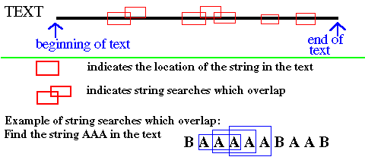
FIGURE 1
- Tries are used to implement the dictionary abstract data type (ADT) where basic operations like makenull, search, insert, and delete can be performed.
- They can be used for encoding and compression. (To be done in a later lecture.)
- They can be used in regular expression search and approximate string matching.

Regular expression
A regular expression is a way to define a pattern of characters. One example of a regular expression is [aB]*[cd][efg] where * is an indicator of repetition. The above expression represent any string with the following properties:
The string starts with any (possibly zero) number of a or B
followed by exactly one of c or d
followed by exactly one of e or f or g
Example: aaace and Bdg are two strings which can be represented by the above regular expression.
Another example of a regular expression is ^.*$ where ^ denotes the beginning of a line, the dot is a wildcard that represents any symbol and $ denotes the end of a line. Therefore, the expression ^.*$ represents a line containing any string repeated any number of time. That is, a whole line.
In UNIX, there is a command called grep which is used to report all matching substrings in a file.
We can type the command: grep '[aB]*[cd][efg]' <filename> and all substrings defined by this regular expression contained in <filename> will be listed.

Structure of a trie
-A trie is a k-ary position tree.
-It is constructed from input strings, i.e. the input is a set of n strings called S₁,S₂,...,S_{n}, where each S_{i} consists of symbols from a finite alphabet and has a unique terminal symbol which we call $.
Some examples of alphabets are:
- {0,l} for binary files.
- {all 256 ASCII characters}
- {a,b,c,d,...,x,y,z}
Tries are not only used to search for strings in normal text, but also to search a pattern in a picture. Here, the picture can be a gif file.

Kinds of tries
- Non compact tries.
- Compact tries.
- Tries called "PATRICIA" which are even more compact.
- Suffix tries.
- Suffix trees.

Non compact tries
A non compact trie is one in which every edge of the underlying tree represents a symbol of the alphabet. (In the following example and for the rest of the this page we will always assume that the symbols in our alphabet are the CAPITAL letters A..Z with terminal symbol $)
Let's construct the trie from the following 5 strings: BIG, BIGGER, BILL, GOOD, GOSH.
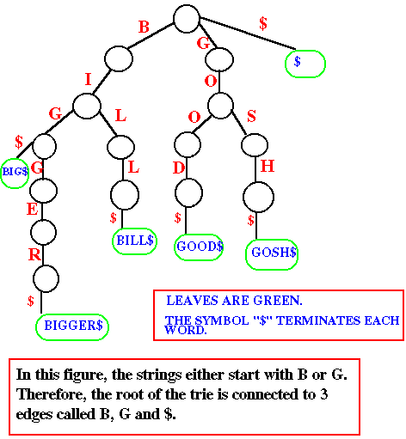
FIGURE 2
When we look for the string GOOD, we start at the root and we follow the G edge, followed by the O edge, another O edge and finally the D edge.
If we want to look for the string BAD, we start from the root, follow the B edge and find out that there is no A edge after. Thus BAD is not in the text.
The above structure is rather wasteful because each edge represents a single symbol. For huge texts this is an enormous waste of space. Instead, we must find a way to represent the trie in a more compact form.
Before building a compact trie, let's look at 2 types of implementation for tries.
- The first implementation uses an array of pointers.
Each array cell has an index. If the alphabet is from A to Z, the array indices will range from A to Z plus the terminal symbol $, so the size of the array is equal to the alphabet size plus 1.
Here is an array representation for the strings BIG and GOO (in figure 3). A string start with either a B or a G. This is why in the first array, cell B and G have children to point to. The other cells have NIL pointers. For example, no word starts with the letter A, so cell A has a NIL pointer.
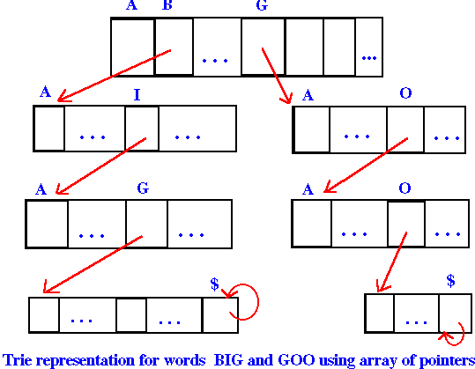
FIGURE 3
This implementation is wasteful when we have few words because most of the pointers are NIL.
- The second implementation uses linked lists and is due to "de la Briandais".
Each node of the linked list represents a single symbol and has pointers to its next sibling and to its first child. Consider the following text:
[s₁...s _{i-1}s _{i}...s_{n}$ s₁...s _{i-1} t₁...t_{m}$]
The first child of s_{k} is s_{k+1} for all k such that 1< k <n (where s_{n+1} = $)
The next sibling of s _{i} is t₁. No other node have a sibling.
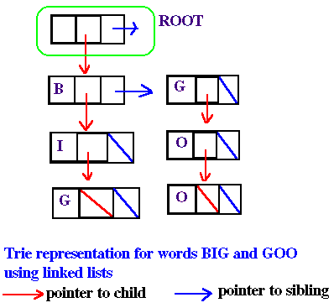
FIGURE 4

Compact tries
This type of trie resembles the one in figure 2 except that chains which lead to leaves are trimmed. This is illustrated in figure 5.
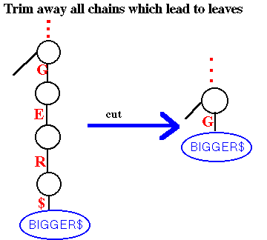
FIGURE 5
The compact form of the trie is in figure 6:
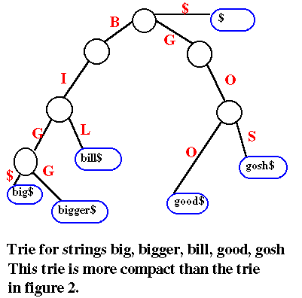
FIGURE 6
The number of leaves is n+1, where n is the number of input strings. Furthermore, in the leaves, we may store either the strings themselves or pointers to the strings (that is, integers).
The compact trie can be even more compacted. This will be discussed under the topic Tries called "PATRICIA".

Tries called "PATRICIA"
"PATRICIA" stands for "practical algorithm to retrieve information coded in alphanumeric". This will be different from the previous trie in that an edge can be labeled with more than one character. Hence, all the unary nodes will be collapsed. The following figure illustrates the collapsing process:
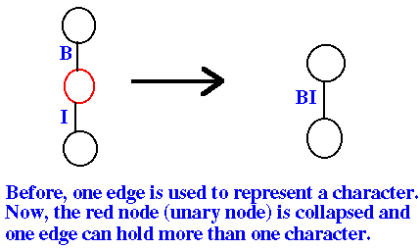
FIGURE 7
The very compact trie will look as follows:
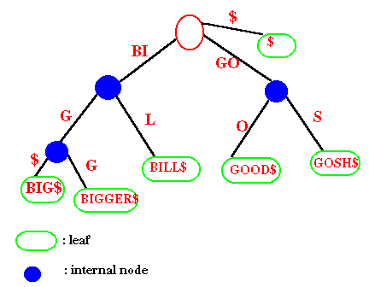
FIGURE 8
Note:
For binary PATRICIA tries (where there are only 2 symbols), the number of internal nodes is equal to the number of leaves minus 1. The height of the PATRICIA trie is bounded by n (the number of leaves). The heights of the ordinary trie or the compact trie are not necessarily bounded by n.

Suffix trie
Principles:
The idea behind suffix TRIE is to assign to each symbol in a text an index corresponding to its position in the text.(ie: First symbol has index 1, last symbol has indice n= #of symbols in text). To build the suffix TRIE we use these indices instead of the actual object.
The structure becomes exogenous and has several advantages:
- It requires less storage space.
- We do not have to worry how the text is represented. (bin, ASCII, etc)
- We do not have to store the same object twice. (no duplicate)
A suffix trie is an ordinary trie in which the input strings are all possible suffixes.
A suffix of a text [t₁ ... t_{n}] is a substring [t _{i} ... t_{n}] where i is an integer between 1 and n.
To demonstrate the structure of the resulting tree we will build the suffix trie corresponding to the following text:

TEXT: G O O G O L $
POSITION: 1 2 3 4 5 6 7
We begin by giving a position to every suffix in the text. We can now build a SUFFIX TRIE for all n suffixes of the text.
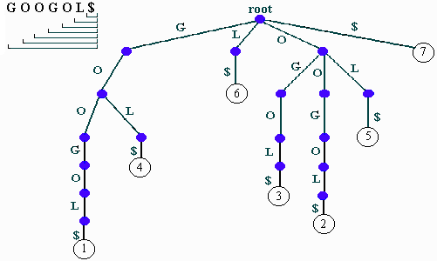
FIGURE 9
Note: The resulting tree has n leaves and height n.

Suffix tree
The suffix tree is created by TRIMMING (compacting + collapsing every unary node) of the suffix TRIE.
The following is a picture of a suffix trie. The corresponding suffix tree is drawn below.
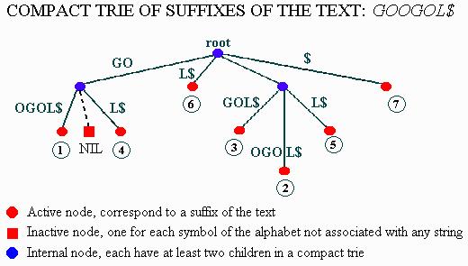
FIGURE 10
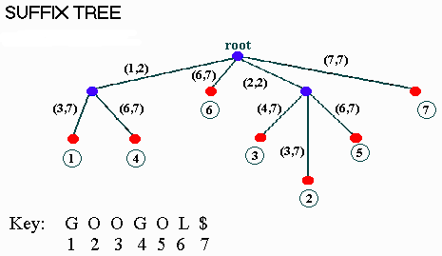
FIGURE 11
We store pointers rather than words in the leaves. And we replaced every string by a pair of indices, (a,b), where a is the index of the beginning of the string and b the index of the end of the string. i.e: We write
- (3,7) for OGOL$
- (1,2) for GO
- (7,7) for $
Remark: This make the storage in a suffix tree strickly O(n).

Search in suffix tree
Searching for all instances of a substring S in a suffix tree is easy since the symbols in S define a path down the suffix tree. Following this path, if we encountered a NIL pointer before reaching the end, then S is not in the tree. If we end up at a node x then S occurs at least once. Moreover the places where S can be found are given by the pointers in all the leaves in the subtree rooted at x.
Pseudo-code for searching in suffix tree:
SEARCH
Start at root
Go down the tree by taking each time the corresponding bifurcation
If S correspond to a node then return all leaves in subtree
If S encountered a NIL pointer then S is not in the tree
Ex:
If S = "GO" we take the GO bifurcation and return: GOOGOL$,GOL$.
If S = "OR" we take the O bifurcation and then we hit a NIL pointer so "OR" is not in the tree.

Analysis
If we have
- TRIE
- Alphabet = {0,1}
- Each string consists of infinitely many independent coin-flips
s₁ = 01101111010001....
s₂ = 11010110110101101...
...
s_{n} = 010111011101...
Putting a period in front, each string can be thought of as the binary expansion of a real number between 0 and 1.
- Compact the resulting tree by eliminating all chains leading to leaves
If a new string S of length k is to be added in the TRIE, we can expect that the distance between the leaf representing S and the root is approximately log ₂ n. Intuitive proof:
  - Each coin-flip has a 50% chance of being 0 or 1. So starting at any node, we have 50% chance of going left, 50% chance of going right.
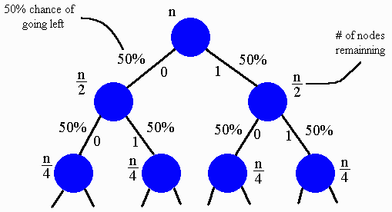
FIGURE 12
  - The process ends with the last digit of S. At that point we have:
n / 2 ^{k} ~ 1 ==> k ~ log ₂ n

Insertion/Growing (Trie & Suffix tree)

Java Applet

The source for this applet.
Theoretically you can construct the suffix tree in time O(n) from a text but this is not a straightforward task, and it is left has an exercise to thereader.

Suffix array
Sort the suffixes & store in a table all the indices.
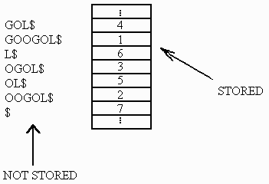
FIGURE 13
In this kind of representation if we look for S = "GOOD" we can use a log ₂ n search algorithm, like binary search, to find its place in the table. In the example we get that if "GOOD" is in the text then it is between 4 and 1. Looking up the string corresponding to suffixes 4 and 1 in the text we see that "GOOD" is not in it.

Links to related material
Many data structures and algorithms courses are "on the web". Some usefulpointers to get you started in your search are given below.
Department of Computer Science, State University of New York | Suffix trees for strings: Longest common substring, shortest common superstring, string matching
University of Minnesota | Generalized suffix trees for biological sequence data: applications and implementation
Glenn Rowe, CS202 at University of Dundee | Storing alphanumeric data using tries
David Eppstein, Department of Information and Computer Science (Universityof California) | String matching
David Eppstein (University of California) | Regular expressions
Jesper Larsson, Department of Computer Science at Lund University | Postscript papers about suffix on words, applications of suffix trees to data compression
University of Helsinki | Publications on suffix trees, suffix arrays, sparse suffix trees (in postscript)
Professor Sugihara, University of Hawaii | Lecture notes on ADT string, string matching, pattern matching

References

Mark Allen Weiss, "Data Structures and Algorithm Analysis in C,"The Benjamin/Cummings Publishing Company, Inc. (1993), 350-351.
Alfred V. Aho, Jeffery D. Ullman, "Foundations of Computer Science," W.H.Freeman and Company, (1992) 216-218, 537-558.
Douglas W. Nance, Thomas L. Naps, "Introduction to Computer Science:Programming, Problem Solving and Data Structures," 3rd Edition,West Publishing Company, (1995), 1172-1175
Zvi Galil, Esko Ukkonen, "Combinatorial Pattern Matching (Vol. 937)," Springer-Verlag Berlin Heidelberg, (1995), 191-203
Derick Wood, "Data Structures, Algorithms, and Performance"Addison-Wesley Publishing Compagny, (1993), 185-229
Graham A. Stephen, "String Searching Algorithms," World ScientificPublishing Company, (1994)

Web page creators
- David Breton - dbreto@po-box.mcgill.ca
- David Huynh -b5cb@musicb.mcgill.ca
- Denis Ricard -dricar@po-box.mcgill.ca
Denis Ricard wrote the Java Applet. David Breton and David Huynh did theHTML editing, pictures, links and references. The material is based on notestaken by David Huynh, David Breton & Evelyne Robidoux.

Copyright &copy1997,by The 3-D's (David Breton, David Huynh & Denis Ricard). All rights reserved. Reproduction of all or part of this work is permitted for educational research use provided that this copyright notice is included in any copy. Disclaimer: this collection of notes is experimental, and does not serve as-is as a substitute for attendance in the actual class.
This web page was last updated March 2, 1997 by David Breton

